PRESS RELEASE

Berlin, 12 May 2026

Valentin Software at Intersolar Europe 2026: New features in PV*SOL and GeoT*SOL for smarter system design

Valentin Software will once again present its powerful design software for photovoltaic, solar thermal and heat pump systems at Intersolar Europe in Munich. From 23 to 25 June 2026, trade visitors can explore the latest versions of PV*SOL premium and GeoT*SOL at booth A4.331.

With the industry-standard PV*SOL premium, photovoltaic systems can now be designed even faster and more precisely. A new, exclusive interface to the data provider Rexplorer enables users to import 3D models of almost all buildings across Germany with a single click. Intersolar visitors can experience the new feature live at the Valentin Software booth.

The heat pump design software GeoT*SOL also continues to evolve. The software is now available in five languages: German, English, French, Italian and Czech. In addition, a modernized interface, refreshed chart colors and new system graphics provide greater clarity and usability when designing heat pump systems.

At booth A4.331, visitors can experience regular live design sessions with PV*SOL premium, and the Valentin Software team of experts will be available for practical advice. This year, the international sales partners Kielgo (Poland) and Solsta SAS (Chile, Colombia, Costa Rica, Ecuador, Mexico, Peru) will be on site. Exclusively for Intersolar, all trade fair visitors will be offered an attractive discount on commercial user-based licenses of PV*SOL premium, T*SOL and GeoT*SOL.

https://valentin-software.com/en/

ABOUT VALENTIN SOFTWARE
Valentin Software is one of the leading providers of design software for renewable energy systems. Founded in 1988, Valentin Software can look back on more than 30 years of company history. With the brands PV*SOL, T*SOL and GeoT*SOL, the Berlin-based company develops powerful, manufacturer-independent software solutions for the design and simulation of photovoltaic, solar thermal and heat pump systems. Its customers include engineers, system designers, installers and architects as well as manufacturing companies from the electrical, heating and building technology sectors. With 18 sales partners in 26 countries, Valentin Software has an international network for sales, support and training. https://valentin-software.com/en/

ABOUT OUR PRODUCTS

PV*SOL premium is the professional software for 3D design and simulation of photovoltaic systems – including precise shading analysis. For more than 25 years, engineers, planners, and installers worldwide have relied on this industry standard to optimally design PV systems, reliably calculate yields, and create bankable reports. Whether for residential homes or commercial rooftops, for full or surplus feed-in, or in combination with battery storage, electric vehicles, and heat pumps – PV*SOL premium models every system configuration realistically and flexibly.
https://valentin-software.com/en/products/pvsol-premium/

GeoT*SOL is the professional software for planning and designing heat pump systems, both in existing and new buildings. The program offers a choice of different heat sources (air, water, geothermal), operating modes and numerous system configurations for every location. Photovoltaic and solar thermal systems can also be seamlessly integrated into the design. Based on a dynamic minute simulation, electricity consumption, seasonal performance factors, operating costs and other system data can be calculated, taking into account blocking periods and tariffs. Finally, key results are compiled in a freely customizable project report for the customer. https://valentin-software.com/en/products/geotsol/

T*SOL is a dynamic simulation program for designing and calculating solar thermal systems. With T*SOL, systems can be optimally designed, collector arrays and storage tanks dimensioned and the economic efficiency calculated. T*SOL offers over 200 pre-configured systems and extensive design aids. After the simulation, a professional project report is generated, containing all system data as well as detailed simulation and profitability results. https://valentin-software.com/en/products/tsol/

IMAGE MATERIAL

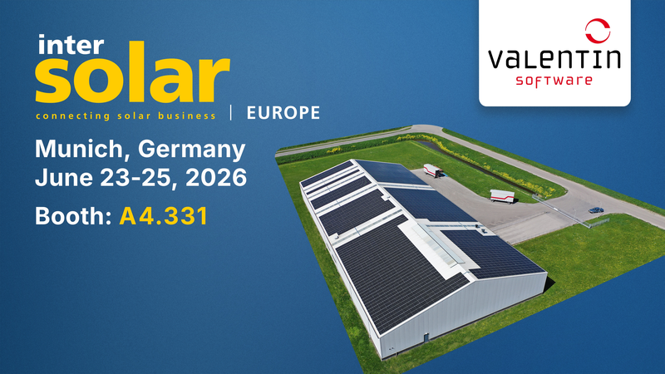 | 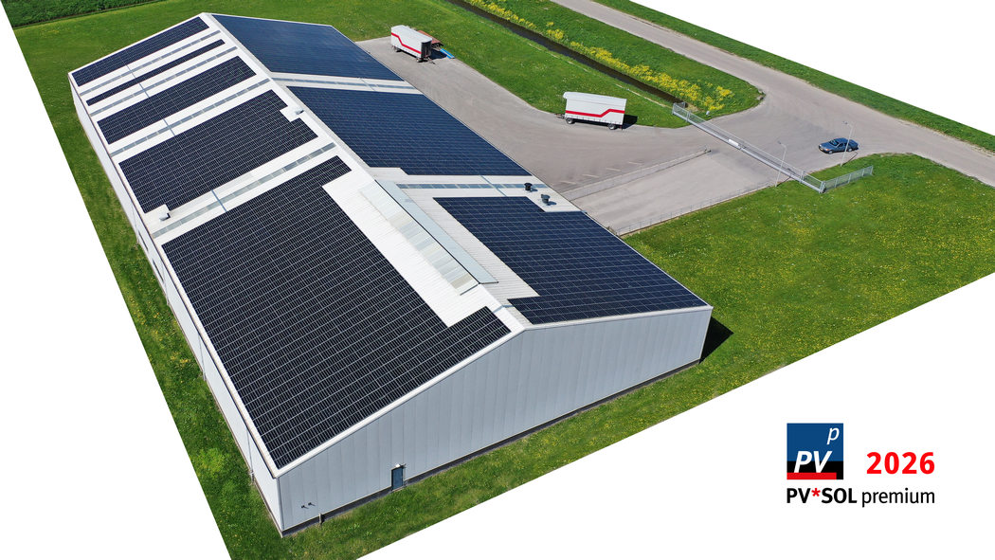
Image caption Intersolar 2026: Valentin Software at Intersolar Europe 2026 | Image caption PV*SOL premium 2026: PV*SOL premium 2026, Photovoltaic system on C&I roof
Copyright: © iStock.com/Mauvries | Copyright: © iStock.com/Mauvries
Download: Ratio 16:9 | Download: Ratio 16:9

Reprint free of charge, please send us a sample copy. If you have any questions, please do not hesitate to contact us.

EDITOR AND PRESS CONTACT
Valentin Software GmbH
Stralauer Platz 34, 10243 Berlin
Tel: + 49 (0)30 588 439 – 0 | Fax: + 49 (0)30 588 439 – 11
Email: presse@valentin-software.com

PV*SOL premium is the professional software for 3D design and simulation of photovoltaic systems – including precise shading analysis. For more than 25 years, engineers, planners, and installers worldwide have relied on this industry standard to optimally design PV systems, reliably calculate yields, and create bankable reports. Whether for residential homes or commercial rooftops, for full or surplus feed-in, or in combination with battery storage, electric vehicles, and heat pumps – PV*SOL premium models every system configuration realistically and flexibly.

